Sprint 3 Report

Team Member | Student Number
Evan Romano | 251327329
Joseph Toma | 251283541
Mohammed Alamen Qassab | 251285296

Sprint Objectives
The goal of Sprint 3 was to:
- Complete manufacturing of the redesigned mechanical components
- Assemble the updated robot platform with the new chassis and camera mount
- Continue development and integration of AprilTag detection
- Begin testing of vision-based navigation using AprilTags
- Prepare the system for final demonstration and project showcase
By the end of the sprint, we aimed to have a physically assembled robot with partial vision-based navigation capabilities and a system ready for final testing and presentation.

Steps to Achieve the Sprint Goal

Mechanical Manufacturing & Assembly
Mechanical development progressed from finalized CAD models to physical implementation.
- 3D printed the optimized chassis design with reduced material and print time
- Implemented frame-based chassis structure to improve print efficiency while maintaining rigidity
- Replaced the custom ball mount design with a LEGO-compatible rear support mount for simpler integration
- Removed rear wheels to complete the transition to the tank-drive configuration
- Installed the fixed camera mount and repositioned the camera from the servo gimbal to a stable forward-facing position
The redesigned components were successfully integrated onto the robot platform, resulting in a simplified and more robust mechanical system.

Software Development & AprilTag Integration
Software development focused on extending vision capabilities beyond obstacle detection.
- Continued development of the AprilTag detection pipeline using grayscale camera input
- Tested detection under controlled conditions with prepared tag layouts
- Began integration of AprilTag detection with robot motion logic
At this stage:
- AprilTag detection code is functional at a basic level
- Full integration with autonomous navigation is still in progress
- Existing obstacle detection and turning behaviour using grayscale vision remains functional
Testing was initiated late in the sprint due to manufacturing timelines, limiting the extent of full system validation.

System Integration & Testing
- Assembled the mechanical and electrical subsystems into a single platform
- Verified that drivetrain and camera systems function correctly after integration
- Conducted initial testing of combined mechanical and software systems
The robot successfully demonstrates:
- Forward motion using front-wheel tank drive
- Obstacle detection and turning using grayscale vision processing
- Stable operation with the redesigned chassis and camera configuration

Demo Link
Due to time constraints between final manufacturing and testing, a full AprilTag navigation demo video is not available for this sprint. Instead, documentation of completed system integration is provided, including images of:
- Fully assembled robot platform
- Manufactured chassis, camera mount, and rear support system
- Final hardware configuration ready for testing and demonstration
These materials verify that the system has progressed to a fully integrated and testable state in preparation for final validation.
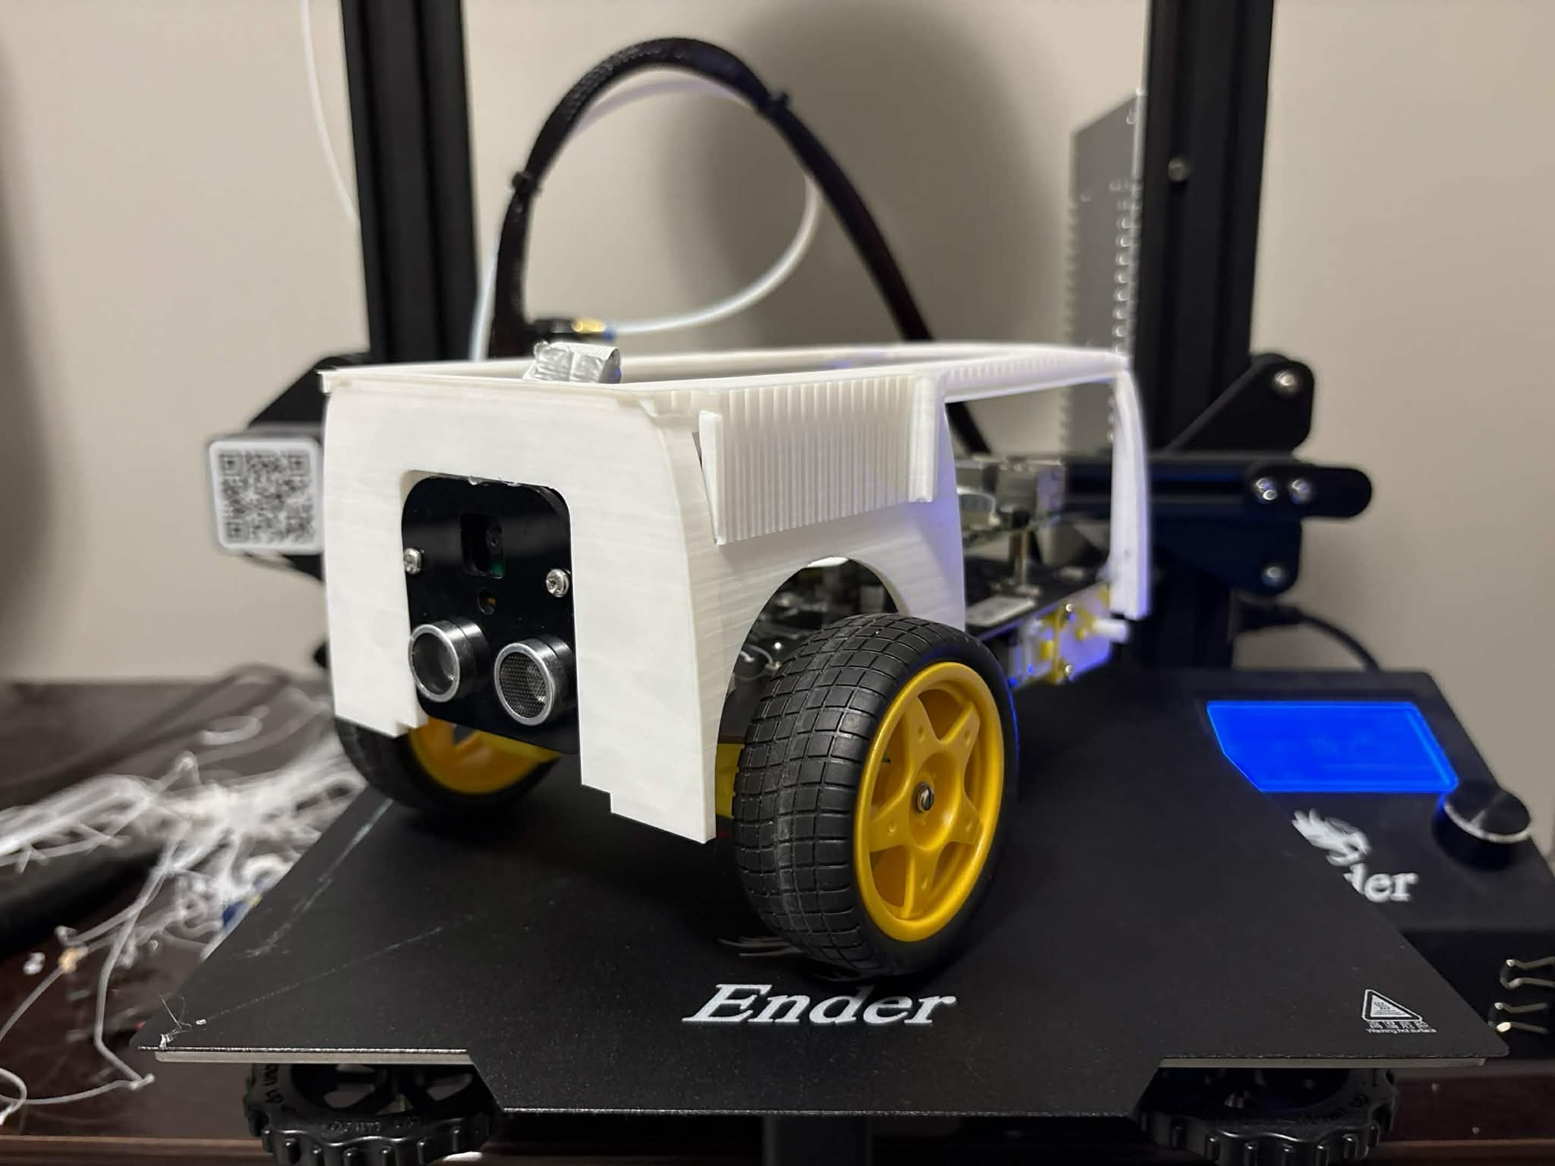
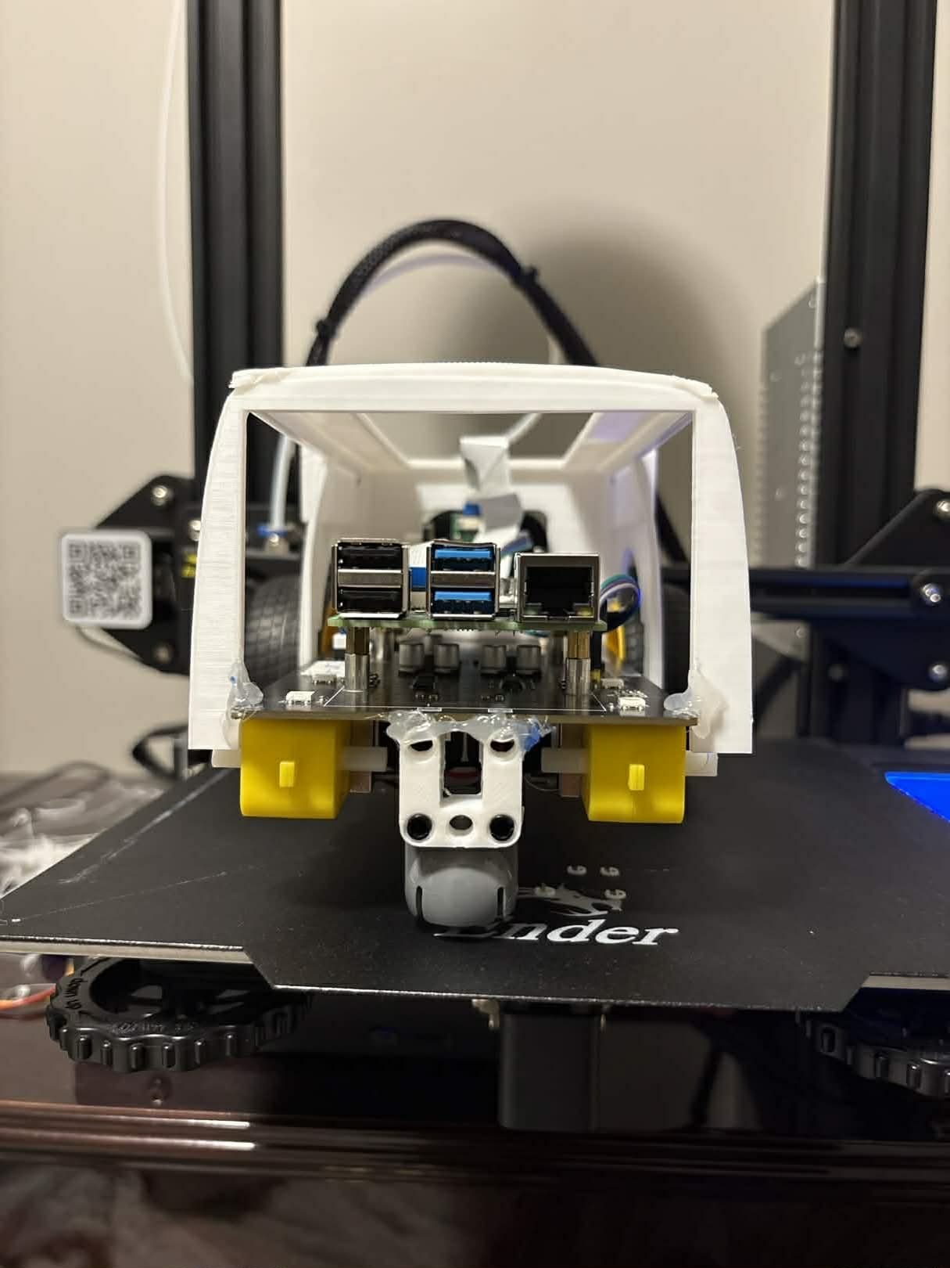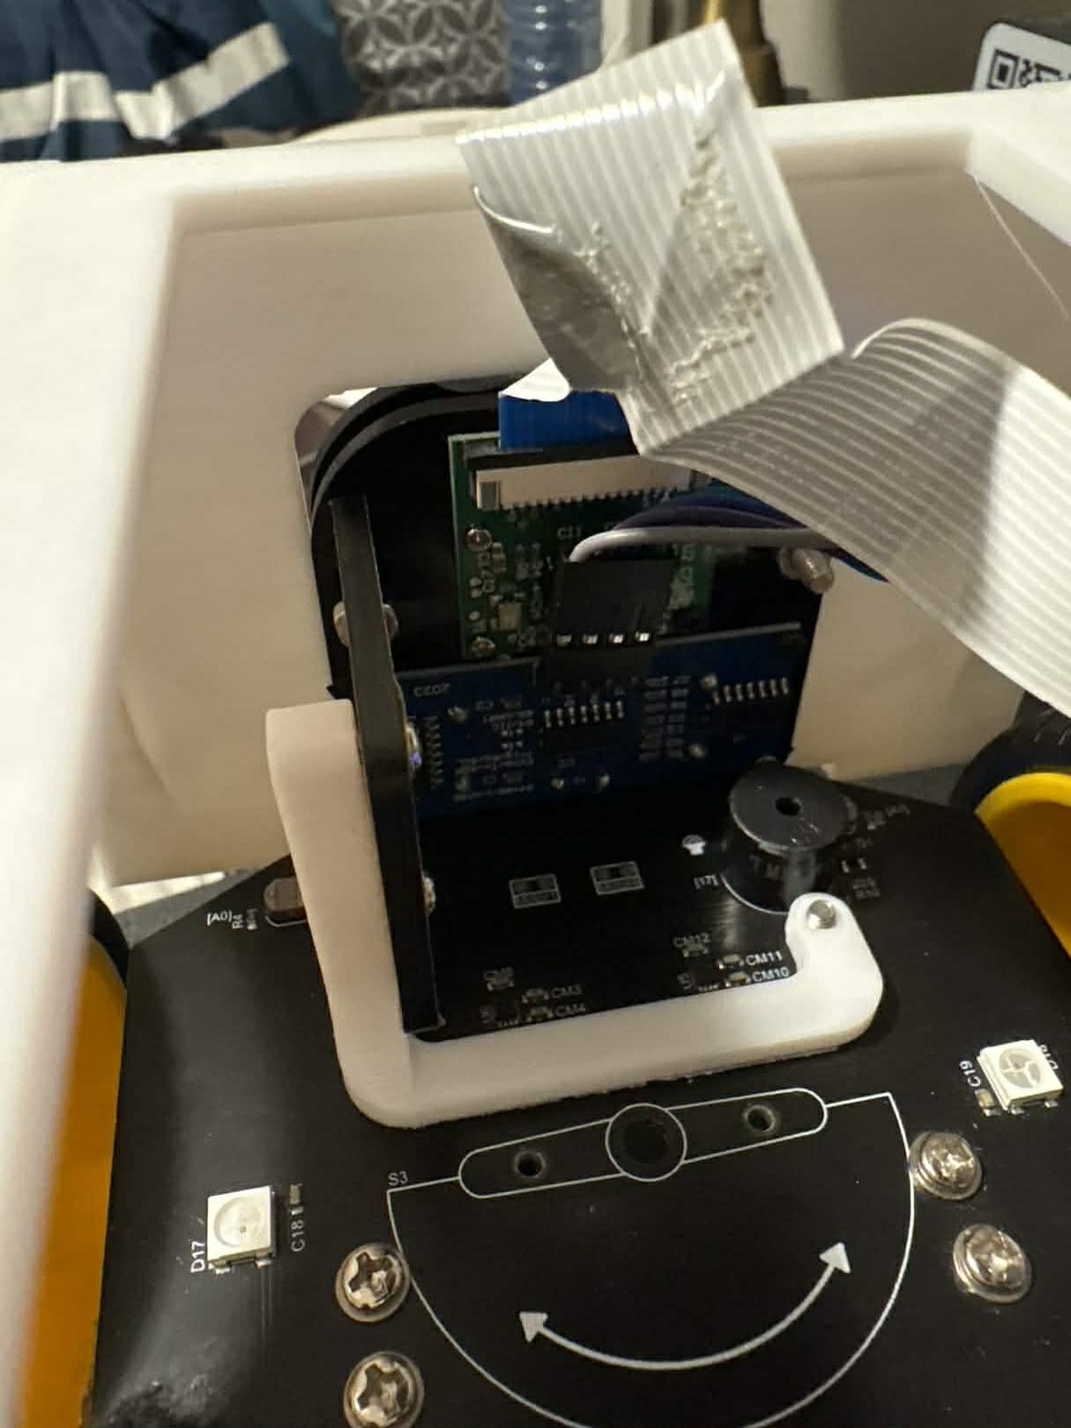

Review & Retrospective

What Went Well During This Sprint?

Mechanical Implementation Completion
The transition from CAD to physical components was successfully completed. The optimized chassis design reduced print time significantly while maintaining functionality, allowing rapid progression to system assembly.

System Integration Progress
The team successfully integrated mechanical and software subsystems into a working platform. The robot maintains stable motion and obstacle detection behaviour after redesign implementation.

Design Adaptability
Key design decisions, such as replacing the custom ball mount and simplifying the chassis, improved overall system feasibility and reduced complexity during final stages.

What Didn’t Go Well / What Can Be Improved?

Limited AprilTag Integration
Although AprilTag detection development progressed, full integration with navigation was not achieved within the sprint.
Causes: Late start on physical testing due to manufacturing timeline constraints.
Improvements: Begin testing in parallel with manufacturing where possible and integrate features incrementally rather than waiting for full system readiness.

Tight Timeline for Testing & Validation
Testing was compressed into a short time window after component fabrication.
Causes: Dependency on the completion of physical components before full system testing.
Improvements: Better scheduling of fabrication and earlier preparation of testing environments to allow immediate validation once hardware is ready.

Incomplete Demonstration Material
A complete demonstration of AprilTag-based navigation was not finalized during this sprint.
Improvements: Prioritize capturing demo content immediately after achieving partial functionality rather than waiting for full system completion.

Next Steps
- Finalize AprilTag detection and integrate with navigation logic
- Perform full system testing and validation of autonomous behaviour
- Prepare and deliver the project showcase demonstration
- Complete final project report with design, implementation, and testing documentation
- Clean and organize the GitHub repository (code, CAD files, documentation) for submission

